Trace Testing

One of the big projects this quarter is to ensure that our charging circuit works. On a very basic level, our charging circuit is made up of three parts: 1. Solar Cells, 2. EPS. 3. Batteries. The solar cells are our power generation. We are getting them [Pumpkin](https://pumpkininc.com/space/datasheet/2021_Pumpkin_PMDSAS_Design_Guidelines.pdf). The Pumpkin cells are a combination of the solar cells themselves, the structure to hold them together, a temperature sensor, and the electrical circuitry comprised. The connector on the Pumpkin system is an 8 pin Hirose harness, shown below. It is unknown as of now if the connector is male or female, and if it’s single row or double row.

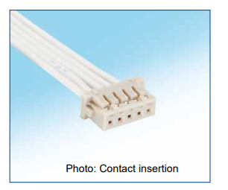

The 8 pins on the Hirose connector are really four pins doubled over. There are two Positive pins, two Return pins, two Telemetry pins, and Two Common pins. It is to my understanding that we need at least one Positive and one Return pin connected to our EPS. On our EPS we have four, four pinned 5040500491 Molex female connectors, as shown below. There are four connectors as at the time of the design, the assumption was to use four solar panels. As of right now, it is unknown which pin does what.

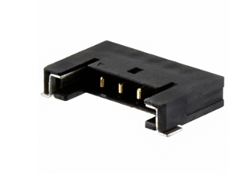

The EPS is designed to regulate both the charging and discharging circuit and the algorithms used. Some algorithms are passive (like having a static IC step down voltage to a set voltage) and some are active (a Mosfet determining how much voltage/current flows through). The EPS is also in charge of battery protections, ensuring that we do not over current, or over/under voltage the battery and prevent thermal runaway, as we are dealing with lithium-ion batteries. To do this, the current generated from the solar cells needs to travel through multiple ICs, some of which can impede the current flow, especially with our STM turned off. To ensure that we can get a proper charge through our EPS and to our batteries we need to cross reference with our board [schematic](https://drive.google.com/drive/u/2/folders/1Q3YjUQNlnxEvFTqKssRiZV9xJ5-UMdYf) and perform trace tests.

A trace test is where we send small voltages into our input to determine if there are any shorts, opens, irregulates in the PCB design. Our trace test would help us determine the pin layout of the EPS’s 5040500491 Molex, and that there aren’t any active components that would inhibit simple circuit charging. The specific details still need to be determined, but an initial 0.5V input, with an incremental step up should work. Our system should be able to handle at least 4V per input, for each 5040500491 Molex connector. The overall system is rated for 12V.

The end point of our trace testing on the EPS is the battery connection which is connected a two pin 22272021 Molex header shown below. We currently don’t have a formal battery package to store our batteries, we will simply connect a Li-ion battery and compare voltage before and after connection to prove charging.

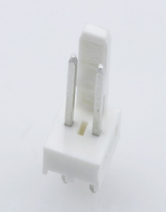

Update: 1/30/24

After reviewing the schematic a little bit, the male connector for the solar cell connections is some variant of the [15132 Molex](https://www.molex.com/en-us/products/part-detail/151320400) series, which is shown below. The female connector has two power and two ground connections. The outer two pins are power, the inner ground. This means that we will be using four of the eight pins of the Hirose connector, two Positive and two Return. Until a formal connector can be found, we might just splice the two wires together.

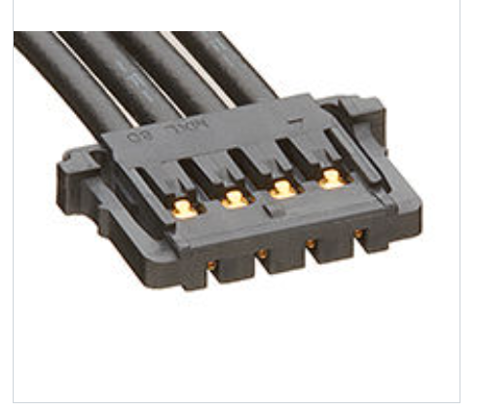

In performing the trace test, we will start from the “Bottom” connection which is supposed to be the bottom solar cell. The location of “Bottom” on the PCB schematic is in the upper right corner, and is on the bottom of the board are shown below.

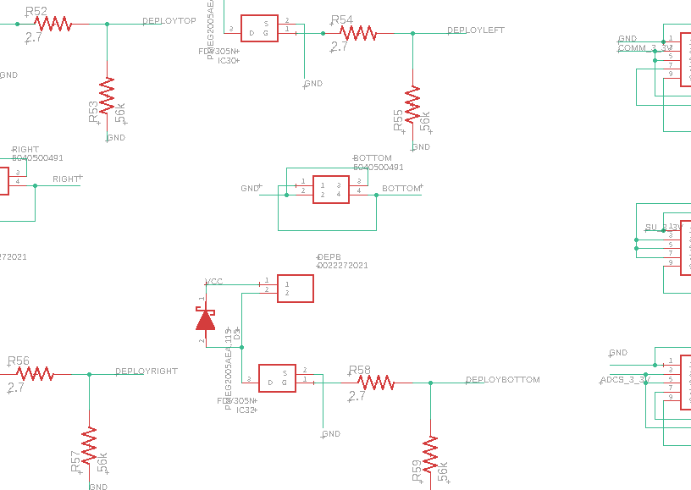

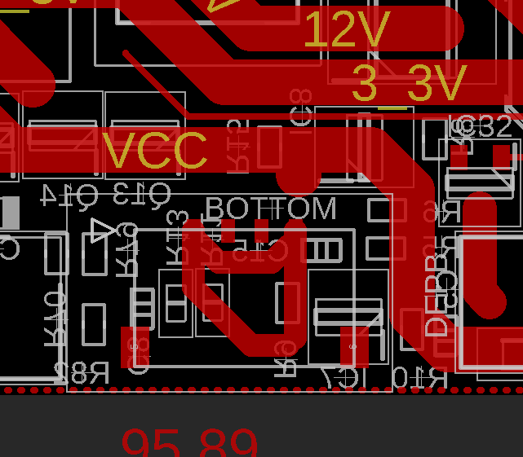

These two connections are transferred to the net Bottom1, which goes across R9, which becomes the net N$24.

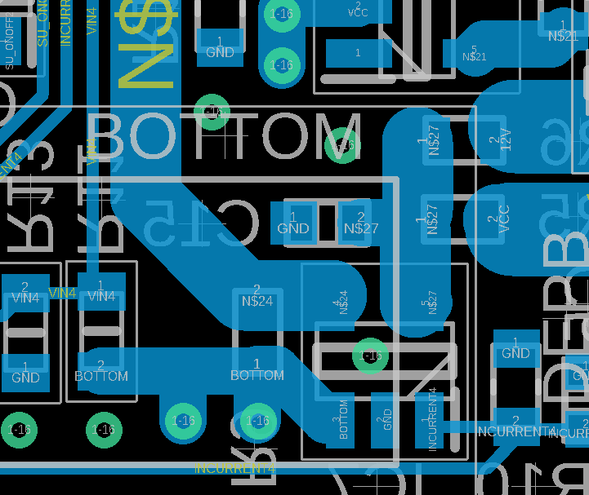

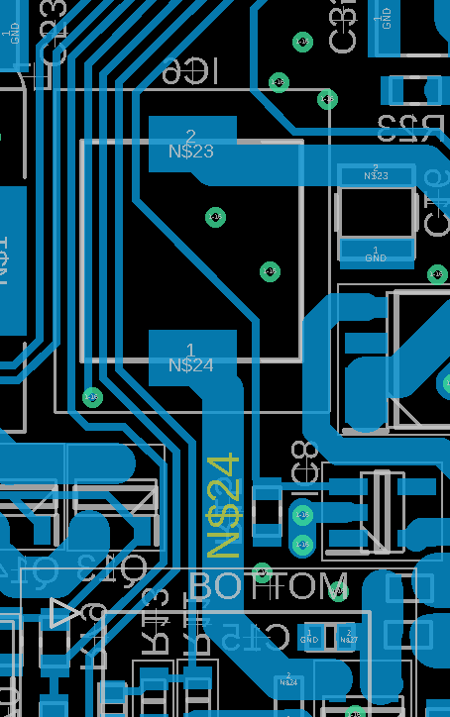

Once we are across IC6, which is an inductor, we continue with N$23, which takes us to L1, another inductor.

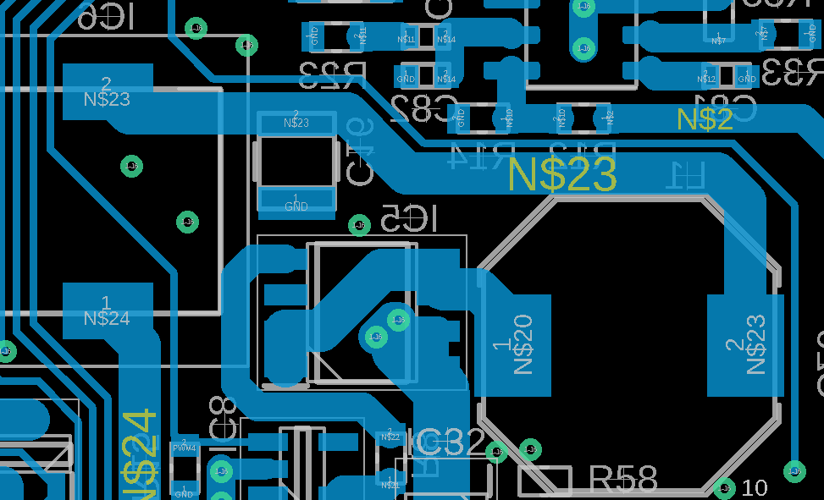

Once we cross L1, we continue on net N$20, across IC5, which is an N-channel mosfet. This takes us to the 12V line

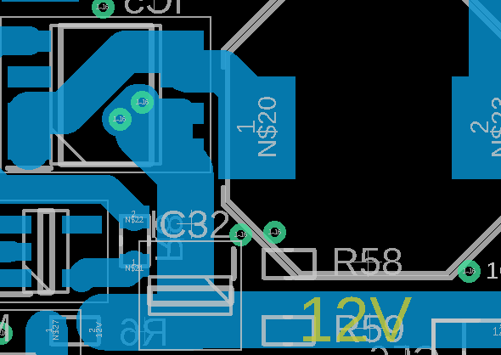

Once on the 12V line, we go back to the top side, and are traced to the 12V line in the upper left hand corner.

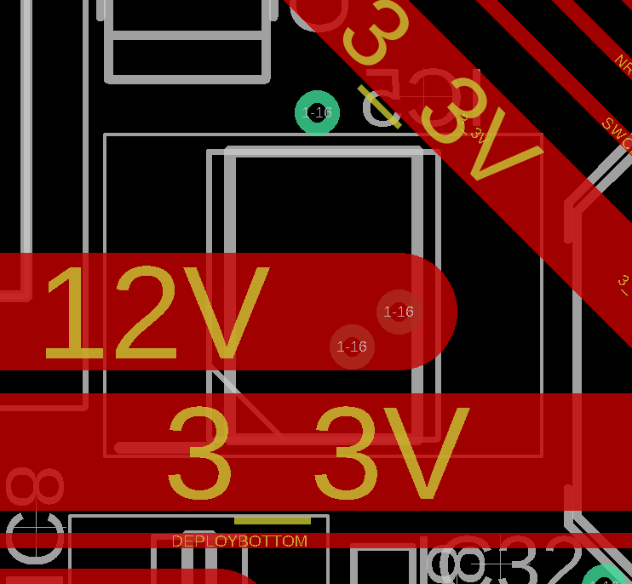

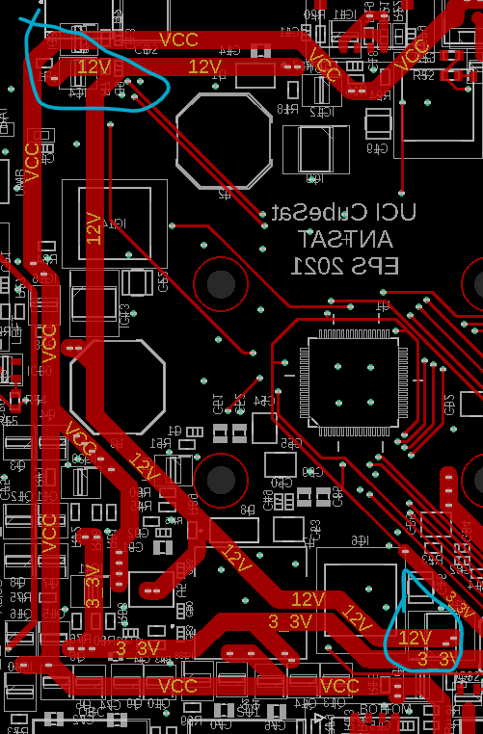

Once there, we go back to 12V bottom and go across R1 to get us to N$19 and into J3.

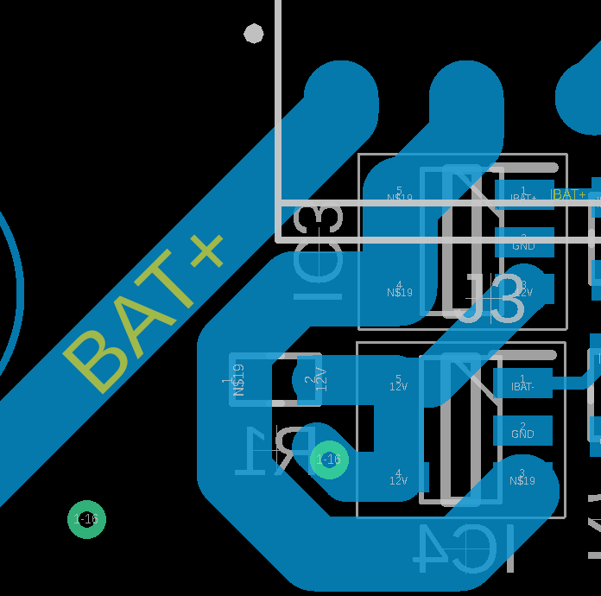

Across J3, we go from N$19 to Bat+ which takes us to our battery pin.

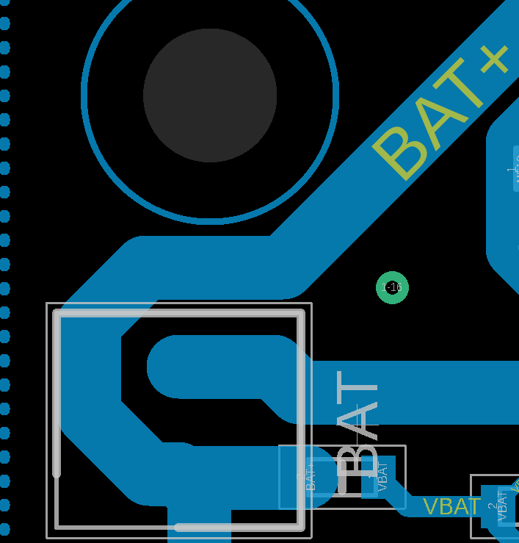

In short: Bottom (top), Bottom1(bottom), across R9, N$24(bottom), across IC6, N$23(bottom), across L1, N$20(bottom), across IC5, 12V(bottom) to 12V(top), move to the top left corner, 12V(bottom), across R1, N$19(bottom), across J3, Bat+(bottom)

Throughout this trace, we have three active and passive circuit elements: IC6, L1, and IC5. IC6 is an inductor and has a maximum amperage of 2.2A. L1 is rated for 2.1A. Neither have a voltage rating. The IC6 is a mosfet/ diode combo. The Mosfet gate voltage is connected to a mosfet controller which requires Vcc and PWM4 to be powered. Will have to test if that will impede the trace test.   
  
  
  
Testing procedure:  
  
The trace test requires a power supply, alligator clips, a MOLEX male header, a wire stripper, and a multimeter. Procedure: we take the MOLEX male header and cut it half way exposing its wires. Connect the outer two wires together and the inner to wires together. The outer wires are out positive voltage and the inner wires are out ground. Connect the MOLEX to the PCB header. We connect the appropriate alligator clips. We turn on the power supply, and input 1v. There are three ICs between the "Bottom" input and the battery output: IC5, IC6, and L1. Check voltage/current across each one. Check voltage/current at battery output. Step voltage up 1.5v. Rinse and repeat until we get to about 4V. Assuming we are getting 4v at the battery side, we connect a battery with SOC not 100%, and see if we get any charging.